NAMES:Angelique MUSHIMIYIMANA

REG NO:21RP08575

COLLEGE:RP IPRC MUSANZE

DEPARTMENT:ELECTRICAL AND ELECTRONIC ENGINEERING

PROGRAM:ELECTRICAL AUTOMATION TECHNOLOGY

MODULE NAME:INDUSTRIAL SENSOR TECHNOLOGY

MODULE CODE:AUTST601

PREPARED MINI PROJECT IN THIS MODULE.

PROJECT NAME : SECULITY SYSTEM USING ULTRAAONIC SWNSOR.

The principle of working of an ultrasonic sensor is easy. The sensor

transmits ultrasonic sound waves and waits for reflected sound waves. After receiving reflected sound wave or usually named echo, sensor detects the distance in different ways.

What is an Ultrasonic Sensor? An ultrasonic sensor is an instrument that measures the distance to an object using ultrasonic sound waves. An ultrasonic sensor uses a transducer to send and receive ultrasonic pulses that relay back information about an object's proximity.

In This Project we design an Ultrasonic sensor Used to monitor An Security system in different areas.

THE PROJECT OF ULTRASONIC SENSOR USED TO CONTROL SECURITY SYSTEM IS CHOSEN DUE TO THE FOLLOWING REASONS :

* For presence detection, ultrasonic sensors detect objects regardless of the color, surface, or material (unless the material is very soft like wool, as it would absorb sound.) To detect transparent and other items where optical technologies may fail, ultrasonic sensors are a reliable choice.

COMPONENTS NEEDED TO COMPLETE THE PROJECT:

1. ARDUINO UNO BOARD:

**ARDUINO UNO:** is a microcontroller board based on the ATmega328P . It has 14 digital input/output pins (of which 6 can be used as PWM outputs), 6 analog inputs, a 16 MHz ceramic resonator (CSTCE16M0V53-R0), a USB connection, a power jack, an ICSP header and a reset button. It contains everything needed to support the microcontroller; simply connect it to a computer with a USB cable or power it with a AC-to-DC adapter or battery to get started.. You can tinker with your Uno without worrying too much about doing something wrong, worst case scenario you can replace the chip for a few dollars and start over again.

"Uno" means one in Italian and was chosen to mark the release of Arduino Software (IDE) 1.0. The Uno board and version 1.0 of Arduino Software (IDE) were the reference versions of Arduino, now evolved to newer releases. The Uno board is the first in a series of USB Arduino boards, and the reference model for the Arduino platform; for an extensive list of current, past or outdated boards see the Arduino index of boards.

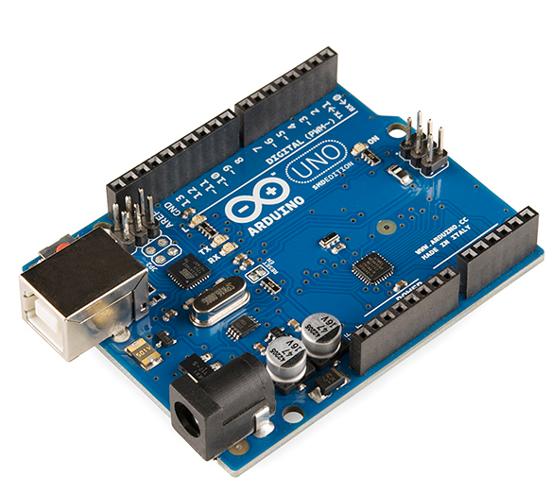

2.ULTRASONIC SENSOR

An ultrasonic sensor is an instrument that measures the distance to an object using ultrasonic sound waves. An ultrasonic sensor uses a transducer to send and receive ultrasonic pulses that relay back information about an object's proximity.

An ultrasonic sensor is an electronic device that measures the distance of a target object by emitting ultrasonic sound waves, and converts the reflected sound into an electrical signal. Ultrasonic waves travel faster than the speed of audible sound (i.e. the sound that humans can hear). Ultrasonic sensors have two main components: the transmitter (which emits the sound using piezoelectric crystals) and the receiver (which encounters the sound after it has travelled to and from the target).

In order to calculate the distance between the sensor and the object, the sensor measures the time it takes between the emission of the sound by the transmitter to its contact with the receiver. The formula for this calculation is [D = ½ T x C](https://www.arrow.com/en/research-and-events/articles/ultrasonic-sensors-how-they-work-and-how-to-use-them-with-arduino) (where D is the distance, T is the time, and C is the speed of sound ~ 343 meters/second). For example, if a scientist set up an ultrasonic sensor aimed at a box and it took 0.025 seconds for the sound to bounce back, the distance between the ultrasonic sensor and the box would be:

|  |
| --- |
| **D = 0.5 x 0.025 x 343** |

3. LEDS:

A light-emitting diode (LED) is a semiconductor device that emits light when an electric current flows through it. When current passes through an LED, the electrons recombine with holes emitting light in the process.

LEDs allow the current to flow in the forward direction and blocks the current in the Light-emitting diodes are heavily doped p-n junctions. Based on the semiconductor material used and the amount of doping, an LED will emit coloured light at a particular spectral wavelength when forward biased. As shown in the figure, an LED is encapsulated with a transparent cover so that emitted light can come out reverse direction.

When the diode is forward biased, the minority electrons are sent from p → n while the minority holes are sent from n → p. At the junction boundary, the concentration of minority carriers increases. The excess minority carriers at the junction recombine with the majority charges carriers.

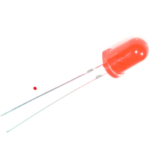

4.BUZZER

An audio signaling device like a beeper or buzzer may be electromechanical or Piezo Electrical or mechanical type. The main function of this is to convert the signal from audio to sound. Generally, it is powered through DC voltage and used in timers, alarm devices, printers, alarms, computers, etc. Based on the various designs, it can generate different sounds like alarm, music, bell & siren.

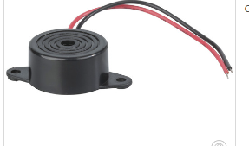

5. JUMPER WIRES:

Jumper wires are simply wires that have connector pins at each end, allowing them to be used to connect two points to each other without soldering. Jumper wires are typically used with Bread board and other prototyping tools in order to make it easy to change a circuit as needed. Fairly simple. In fact, it doesn’t get much more basic than jumper wires .

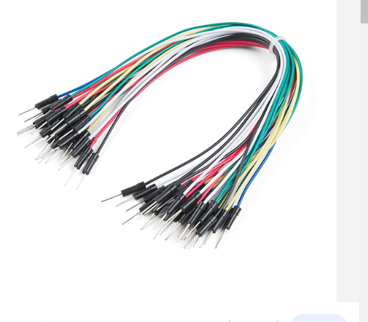

6.BREAD BOARD:

A breadboard, solderless breadboard, or protoboard is a construction base used to build semi-permanent prototypes of electronic circuits. Unlike a perfboard or stripboard, breadboards do not require soldering or destruction of tracks and are hence reusable.

Breadboards are one of the most fundamental pieces when learning how to build circuits. In this tutorial, you will learn a little bit about what breadboards are, why they are called breadboards, and how to use one. Once you are done you should have a basic understanding of how breadboards work and be able to build a basic circuit on a breadboard.

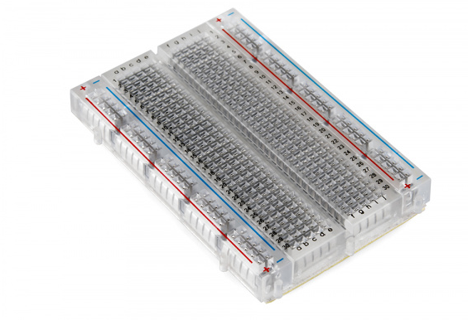

7. RESISTORS

The resistor is a passive electrical component that creates resistance in the flow of electric current. In almost all electrical networks and electronic circuits they can be found. The resistance is measured in ohms (Ω). An ohm is the resistance that occurs when a current of one ampere (A) passes through a resistor with a one volt (V) drop across its terminals. The current is proportional to the voltage across the terminal ends. This ratio is represented by  Ohm’s law .

Resistors are used for many purposes. A few examples include limiting electric current, voltage division, heat generation, matching and loading circuits, gain control, and setting time constants. They are commercially available with resistance values over a range of more than nine orders of magnitude. They can be used as electric brakes to dissipate kinetic energy from trains, or be smaller than a square millimeter for electronics.

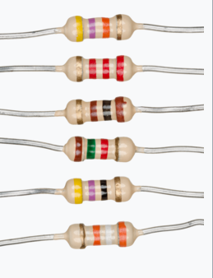

CIRCUIT DIAGRAM BY USING FRITIZING:

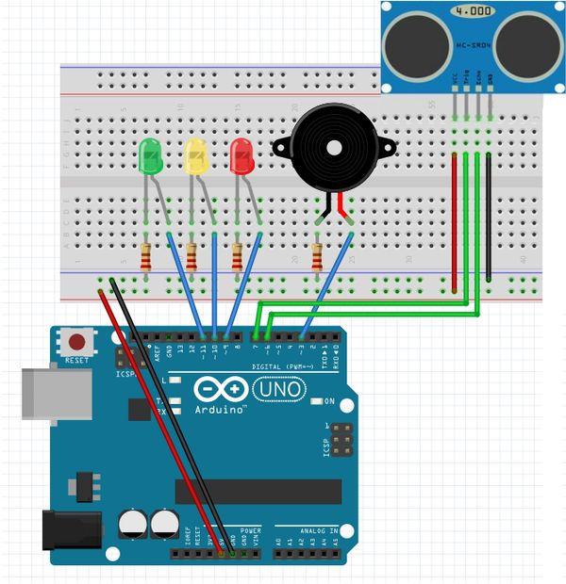

CODES FOR ARDUINO BOARD:

Const int trig = 7;

const int echo =6;

const int LED1 = 11;

const int LED2 = 10;

const int LED3 = 9;

const int buzzer = 9;

int duration = 0;

Int distance = 0;

void setup()

{

pinMode(trig , OUTPUT);

pinMode(echo , INPUT);

pinMode(LED1 , OUTPUT);

pinMode(LED2 , OUTPUT);

pinMode(LED3 , OUTPUT);

pinMode(buzzer , OUTPUT);

Serial.begin(9600);

}

void loop()

{

digitalWrite(trig , HIGH);

delayMicroseconds(1000);

digitalWrite(trig , LOW);

duration = pulseIn(echo , HIGH);

distance = (duration/2) / 28.5 ;

Serial.println(distance);

if ( distance <= 5 )

{

digitalWrite(LED1, HIGH);

}

else

{

digitalWrite(LED1, LOW);

}

if ( distance <= 10 )

{

digitalWrite(LED2, HIGH);

}

else

{

digitalWrite(LED2, LOW);

}

if ( distance <= 15 )

{

digitalWrite(LED3, HIGH);

}

else

{

digitalWrite(LED3, LOW);

}

if ( distance <= 3)

{

digitalWrite(buzzer, HIGH);

}

else

{

digitalWrite(buzzer, LOW);

}

}

WORKING PRINCIPLE OF THE SYSTEM

ULTRASONIC SENSOR WOKING PRINCIPLE:

Ultrasonic sensors are electronic devices that calculate the target’s distance by emission of ultrasonic sound waves and convert those waves into electrical signals. The speed of emitted ultrasonic waves traveling speed is faster than the audible sound.

There are mainly two essential elements which are the transmitter and receiver. Using the piezoelectric crystals, the transmitter generates sound, and from there it travels to the target and gets back to the receiver component.

To know the distance between the target and the sensor, the sensor calculates the amount of time required for sound emission to travel from transmitter to receiver.

*SPECIFICATION OF ULTRASONIC SENSOR.*

Knowing the specifications of an ultrasonic sensor helps in understanding the reliable approximations of distance measurements.

* The sensing range lies between 40 cm to 300 cm.
* The response time is between 50 milliseconds to 200 milliseconds.
* The Beam angle is around 50.
* It operates within the voltage range of 20 VDC to 30 VDC
* Preciseness is ±5%
* The frequency of the ultrasound wave is 120 kHz
* Resolution is 1mm
* The voltage of sensor output is between 0 VDC – 10 VDC
* The ultrasonic sensor weight nearly 150 grams
* Ambient  tempereture is -250C to +700C
* The target dimensions to measure maximum distance is 5 cm × 5 cm

WORKING PRINCIPLE FOR ARDUINO

**Arduino is an open source electronics creation platform** , which is based on free, flexible and easy to use hardware and software for creators and developers. This platform allows you to create different types of single-board microcomputers to which the community of creators can give different types of use.

In order to understand this concept, first you need to know about free hardware and free software concepts. Free hardware are devices whose specifications and diagrams are publicly accessible, so anyone can replicate them. This means that Arduino offers the base **so that any other person or company can create their own boards** , being able to be different from each other but equally functional when starting from the same base.

Free software is a computer program **whose code is accessible by anyone** so that whoever wants to use  can use and modify it. Arduino offers the Arduino IDE (Integrated Development Environment) platform, which is a programming environment with which anyone can create applications for Arduino boards, so that they can be given all kinds of utilities.

The Arduino is a board based on an ATMEL AVR microcontroller. Microcontrollers are **integrated circuits where instructions can be recorded** , which you write with the programming language that you can use in the Arduino IDE environment. These instructions allow you to create programs that interact with the circuitry on the board.

The most used microcontrollers on Arduino platforms are the [Atmega168](http://www.atmel.com/devices/atmega168.aspx" \t "_blank), [Atmega328,](http://www.atmel.com/devices/atmega328.aspx" \t "_blank) [Atmega1280](http://www.atmel.com/devices/atmega2560.aspx" \t "_blank), [ATmega8](http://www.atmel.com/devices/ATMEGA8.aspx" \t "_blank) for their simplicity, but it is being expanded to Atmel microcontrollers with 32-bit ARM architecture and also to Intel microcontrollers.

The Arduino microcontroller has communication ports and input / output ports. with which we can connect different types of peripherals on the board. The information of these peripherals that you connect will be transferred to the microcontroller, which will be in charge of processing the data that comes through them.

On the other hand, Arduino provides us with software consisting of a development environment **[(IDE)](https://en.wikipedia.org/wiki/Integrated_development_environment" \t "_blank)** that implements the arduino programming language, the tools to transfer the firmware to the microcontroller and the bootloader executed on the board. The main feature of the software and the programming language is its simplicity and ease of use.

BREADBOARD WORKING PRINCIPLE

The purpose of the breadboard is to make quick electrical connections between components- like resistors, LEDs, capacitors, etc- so that you can test your circuit before permanently soldering it together. Breadboards have many small sockets on them, and some groups of sockets are electrically connected to each other.

Breadboards have many small sockets on them, and some groups of sockets are electrically connected to each other. On the underside of the board there are many small metal strips which physically connect certain groups of sockets together and allow electricity to flow freely between them.

BUZZER WORKING PRINCIPLE

Magnetic buzzers operate using electromagnetic principles. When power is applied, current runs through the coil of wire inside the buzzer, which produces a magnetic field. The flexible ferromagnetic disk is attracted to the coil when the magnetic field is activated, then returns to rest when the magnetic field is off.

The piezoelectric buzzer uses the piezoelectric effect of the piezoelectric ceramics and uses the pulse current to drive the vibration of the metal plate to generate sound. Piezoelectric buzzer is mainly composed of multi-resonator, piezoelectric plate, impedance matcher, resonance box, housing, etc. Some of the piezoelectric buzzers are also equipped with light-emitting diodes. The multi-resonator consists of transistors or integrated circuits. When the power supply is switched on (1.5~15V DC operating voltage), the multi-resonator oscillates and outputs 1.5~2.5kHz audio signal. The impedance matcher pushes the piezoelectric plate to generate sound. The piezoelectric plate is made of lead zirconate titanate or lead magnesium niobate piezoelectric ceramic, and silver electrodes are plated on both sides of the ceramic sheet. After being polarized and aged, the silver electrodes are bonded together with brass or stainless steel sheets.

LED WORKING PRINCIPLE

Working Principle: A light-emitting diode is a two-lead semiconductor light source. It is a p–n junction diode that emits light when activated. When a suitable voltage is applied to the leads, electrons are able to recombine with electron holes within the device, releasing energy in the form of photons.

The Light-emitting diode is a two-lead semiconductor light source. In 1962, Nick Holonyak has come up with the idea of a light-emitting diode, and he was working for the general electric company. The LED is a special type of diode and they have similar electrical characteristics to a PN junction diode. Hence the LED allows the flow of current in the forward direction and blocks the current in the reverse direction. The LED occupies a small area which is less than **1 mm2**. [The applications of LEDs](https://www.elprocus.com/future-of-led-lighting-and-leds/) used to make various electrical and electronic projects.

JUMPER WIRES WOKING PRINCIPLE

A jumper wire is an electric wire that connects remote electric circuits used for printed circuit boards. By attaching a jumper wire on the circuit, it can be short-circuited and short-cut (jump) to the electric circuit.

APPLICATIONS OF ULTRASONIC SECURITY SYSTEM

* + Loop control
  + Roll diameter, tension control, winding and unwind
  + Liquid level control
  + Thru beam detection for high-speed counting
  + Full detection
  + Thread or wire break detection
  + Robotic sensing
  + Stacking height control
  + 45° Deflection; inkwell level detection; hard to get at places
  + People detection for counting
  + Contouring or profiling using ultrasonic systems
  + Vehicle detection for car wash and automotive assembly
  + Irregular parts detection for hoppers and feeder bowls
  + Presence detection
  + Box sorting using multi-transducer ultrasonic monitoring system.

AS CONCLUTION THIS PROBLEM IS USED TO REDUCE THE SECURITY GATE FOUND THE PROTECT SAME AREAS ,AND REDUCE THE COST SALARY TO THE SECURITY .

AUTOAMATICALLY THI SYSTEM IS BETTER THAN TO THE USING SECURITY .